how to join a meter to a han device (pipit 500/ Puffin energy display)
1.0 Summary of HAN device & communication status on a meter’s LCD
Pipit 500 Display (Fig 1.0)
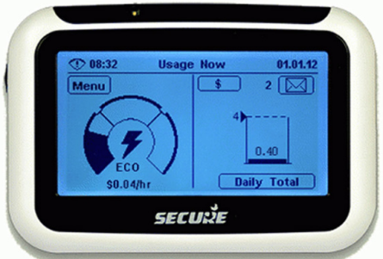
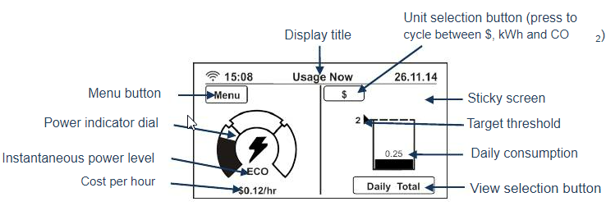
Fig 1.0
Puffin Energy Display (Fig 2.0)
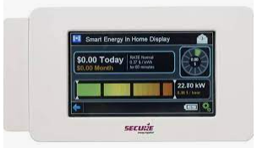
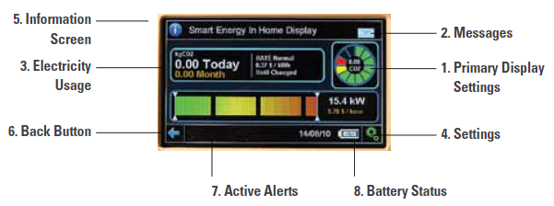

Fig 2.0
HAN Communication Status (Fig 3.0)
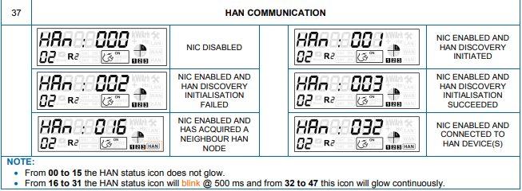
Fig 3.0
2.0 Procedure:
        - Check HAN Device Readiness for Joining
Prior to joining a HAN device to a meter, it must have a HAN certificate loaded. A quick way to check this by conducting the following steps
Pipit 500 (Fig 1.0)
- If the wireless signal is showing up on the HAN LCD screen (see top left corner of the screen), this means this device has already been joined by a meter. The current joined meter ID can be identified by, on the HAN device, selecting Menu -> Info-> I and check for HUB ID (this is the MAC address of the joined meter). This HAN device should be unjoined first by
Select menu->settings->advance->network->enter pin=1793 -> OK (wait for a few seconds, this HAN device will unjoin the existing meter and ready to join the target meter)
- If the signal strength shows an exclamation mark, this means the meter is not currently joining any meter. In this case, no action is required. Proceed to next step
Puffin Energy Display (Fig 2.0)
----------------------------------------

        - Check ESI (Meter) Readiness for Joining
1.0 HAN certificate check
This can be done by connecting an FSU to the target meter then use the command “AppSysvar, Read”,
check Sysvar ID: 392 for HAN cert availability
check Sysvar ID:391 for the public key availability.
If both do exist, then the meter has been loaded with the required certificate (see Fig 4.0).
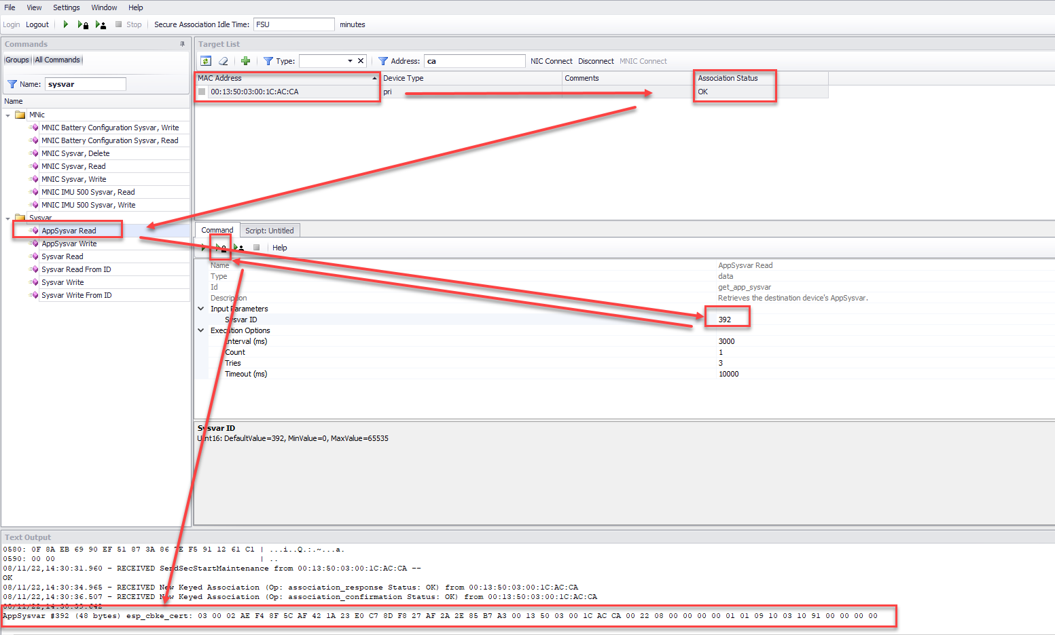
Fig 4.0
Alternatively, scroll through meter’s LCD and check for HAN number. If it is 32 then the meter is ready and connected to a HAN device (see fig 3.0). This means the certificate is available on the meter. Other than number 32, any other HAN numbers will not tell if the certificate is available or not on a meter.
2.0 HAN radio enabled
Ensure the HAN radio is enabled on the target meter. This can be done by using “han_radio_enable” command via UIQ - Network Centre.
        - Prepare and import device files to UIQ (2 files are required: IHD & ESI (Meter))
1.0 Prepare import files
Firstly, check if the target meter & HAN device have previously been loaded to HCM on UIQ, conduct the followings steps
- Logon UIQ, On HCM, select Devices -> HAN Device -> Search
- Repeat a search on ESI. Select Devices -> ESI -> Search
Continue by executing steps below for the missing devices
For IHD (HAN device) import:
Open a template file on V: drive >Burwood test Lab>Document_Final>Templates_Files>HAN import>HCM_2.4_addDevice_Import_HAN_Device. Edit this CSV file and add in new MAC address of the HAN device (MAC can be found on HAN device)
For ESI Device (Meter) import:
Open a template file on V: drive >Burwood test Lab>Document_Final>Templates_Files>HAN import>HCM_Customer Import_Meter. Edit this CSV file and add
    - UtilServicePointID (obtain from AMM->Location)
    - DRMProgramIDs (obtain from HCM->Programs->List) (Fig 5.0)
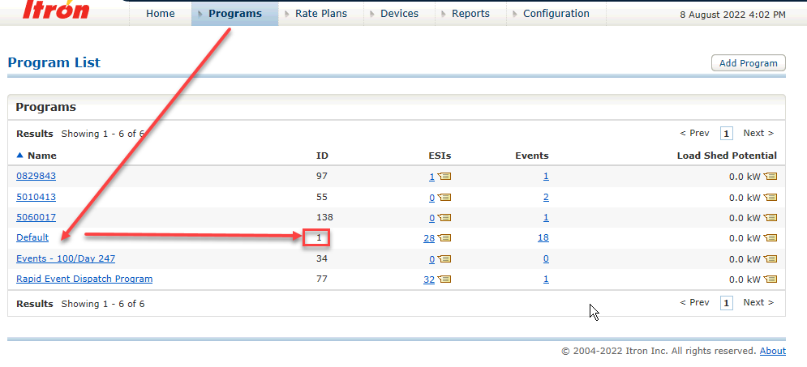
Fig 5.0
    - DRMratePlanID (obtain from HCM->Rate Plans) (Fig 6.0)
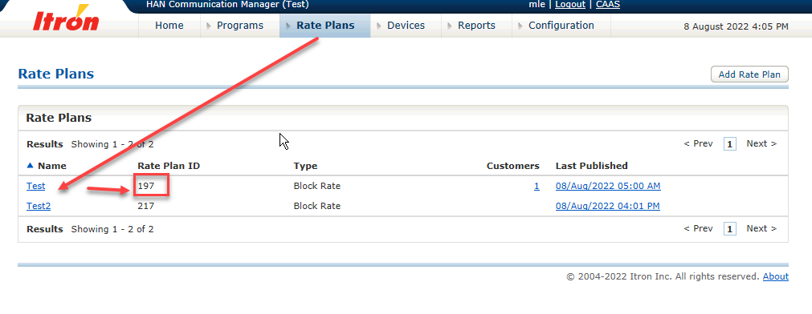
Fig 6.0
** If both DRMProgramID & RatePlanID don’t exist, you need to create one for each then add the ID to the import files.
2.0 Import HAN/ESI files by using HCM (UIQ)
- From UIQ, AMM dropdown, select HAN Communication Manager -> Devices - >Import - > Browse for the CSV file (Excel) and select Import
- Check import status and correct any error if required
- Check imported device by go to HCM - > Devices -> Search and search for the imported IHD (Fig 7.0)
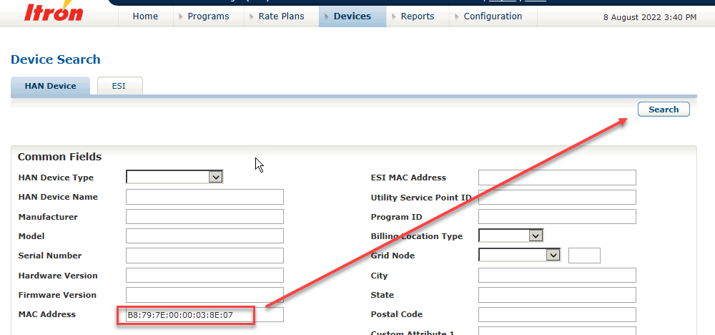
Fig 7.0

        - Sync & Provision meter (esi) BY USING HCM
- Search for the ESI (Meter) recently imported to UIQ (Go to HCM ->Devices -> Search->ESI->Enter meter’s MAC address
- Select meter via its MAC address (Fig 8.0)
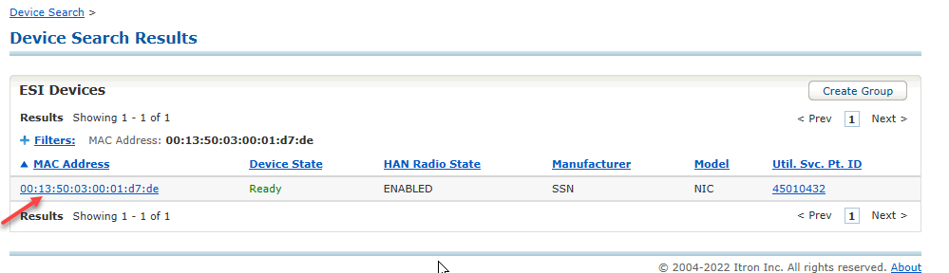
Fig 8.0
- Press the "Provision" button to activate the HAN radio on the meter (the same as of using HAN radio enabled command via CM) and wait for the command to finish and check the result (see Fig 9.0)
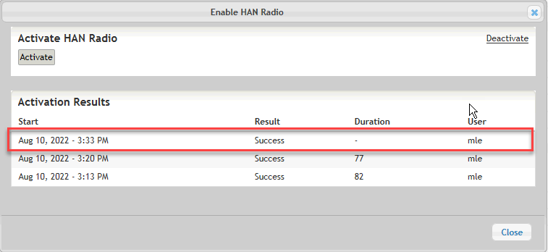
Fig 9.0
- Press the "Sync" button (Fig 10.0) and wait for the command to finish
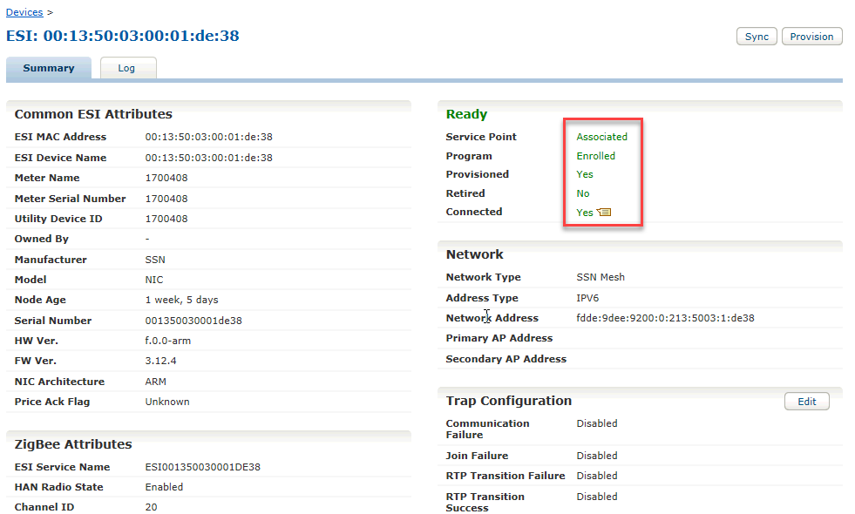

Fig 10.0
- Check that the "ESI Sync: Node Age" (Fig 11.0) under "Latest ESI Sync Status" has updated to the correct timestamp
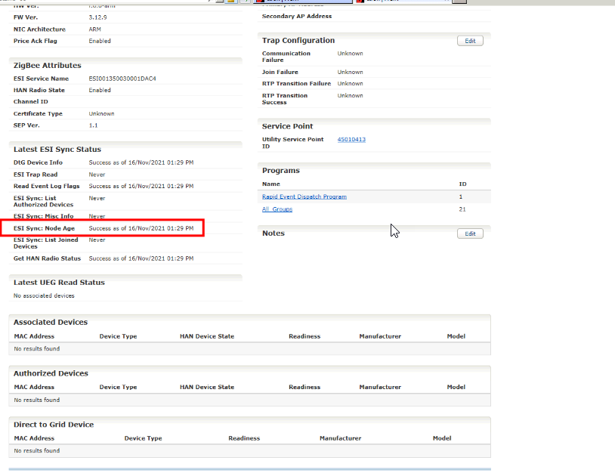
Fig 11.0
        - assocated han device to a meter (esi) BY USING HCM
- Go to HCM >Devices > Search and look for the meter (ESI) which has recently been provisioned. Copy its MAC address
- Go to HCM >Devices > Search and search for the target HAN
- Press the "Edit Associate" button
- Enter the MAC address of the ESI which was previously copied and press Associate
- Go to the IHD details page and check that the HAN device is associated to the correct ESI but not joined
        - joinning a han device to meter (esi) BY USING HCM
      - Go to HCM >Devices > Search (Fig 12.0) and look for the target HAN Device
      - Select Provision->Authorise Device.

Importance: if the authorisation step above fails due to link key is missing (i.e. Install Code and Link Key are missing). To fix this, please follow those steps as listed below

- For HAN Device
Pipit 500
  - Copy the install code from a HAN device (Menu-> Info->Write down the Install Code Number (do not include hyphen sign)
  - On HCM, Devices-> Search->HAN Device->Insert MAC address of HAN device then run search
  - On the HAN device ->Select MAC address then scroll down to Zigbee Attributes ->Edit-> Enter Install Code number (previously copied) to “Pre-Configured Link Key” -> Save then run Provision->Authorisation again.
Puffin Energy Display
---------------------------------------------------------------------------------

- You can check on HCM ->device->ESI for the join result or check on HAN device LCD -> Menu->Info->I for HUB ID (MAC address of the ESI)

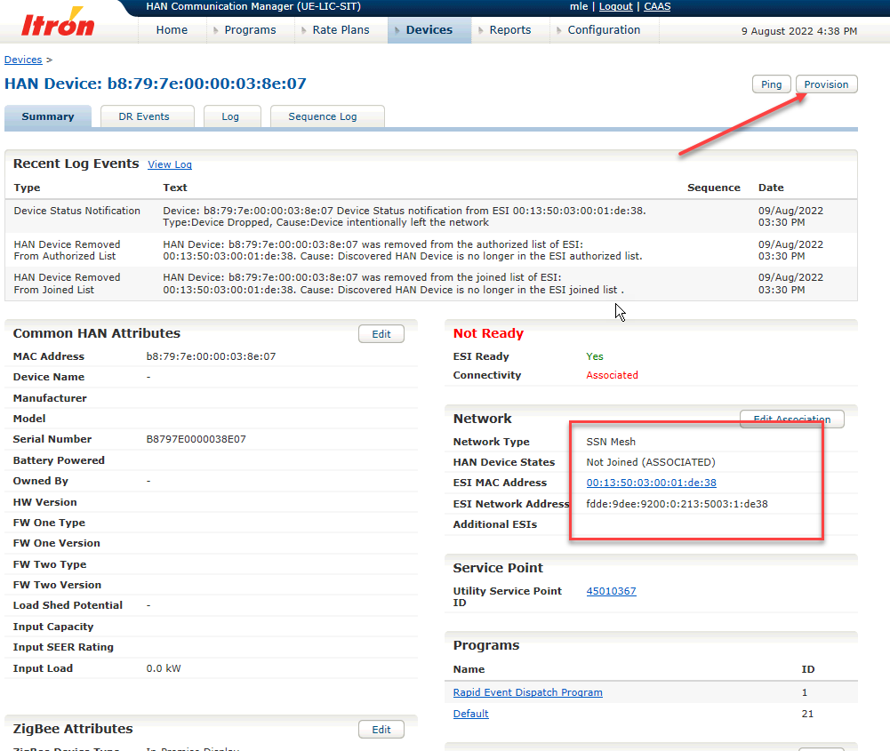
Fig 12.0

